40 W Gearbox Integrated BLDC Motor
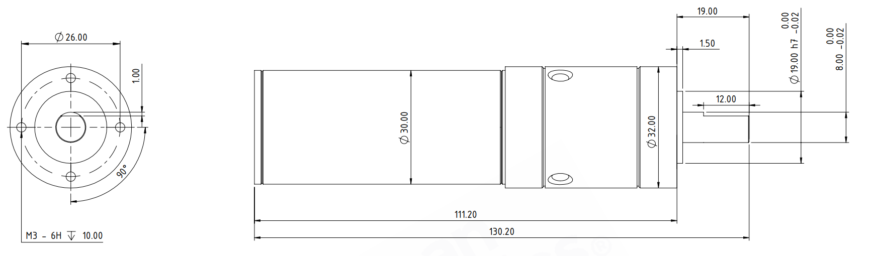
Basic Motor Parameters
Rated Power | W | 40
Rated Speed | rpm | 7500
Rated Torque | Nm | 0,05
Rated Current | A | 2
Rated Voltage | V | 24
No-Load Speed | rpm | 9000
Max. Efficiency | % | 90
Electrical Parameters
Number of Phases |  | 3
Number of Poles |  | 8
Torque Constant (KT) | Nm/A | 0.024
Back EMF Constant (KE) | Vs/rad | 0.025
Terminal Resistance Phase to Phase (±%10) | mΩ | 1200
Terminal Inductance Phase to Phase (±%30) | mH | 0,26
Thermal Data
Ambient Temperature | °C | -40...+85
Max. Winding Temperature | °C | +155
Physical Parameters
Outer Diameter | mm | 32
Shaft Diameter | mm | 8
Max. Lenght | mm | 130.2
Weight | gr | ~231
Motor Connection
U | RED CABLE
V | WHITE CABLE
W | BLACK CABLE
Sensor Connection
BLUE | VDC+
GREEN | GND
BROWN | HALL A
ORANGE | HALL B
YELLOW | HALL C
Connector Articles
Power | N/A
Signal | N/A

